**Notes Manager**

**Bachelor of Science in Information**

**Technology**

**Christian James G. Francisco**

**Rodny Mendoza**

**Ritzmer Alminaza**

**Reyster Caberte**

**June 12, 2024**

**Introduction**

**Demonstration**

To start with our application, run the JAR file of our application, the first scene of our application will be user authentication. If you’re not registered with our application, you can first register an account with your username and password.

**Step 1.**  Create an account with your desired username and passsword(password must be atleast 6 characters long) by filling up the 2 text box and then press the “register” button.

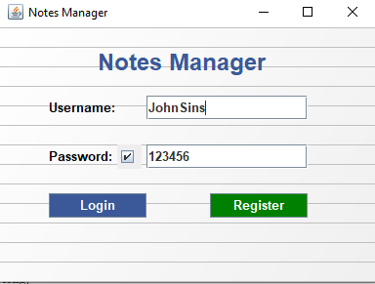

**Step 2.** As you have finished creating your account press the “Login” button to login into the application using the credentials you’ve provided.



**Step 3.** To write notes press the “Write a Note” button on the main menu and it will take you to the Note writer window. In the note writer window, there will be two text box that you need to fill, the title box and the content box(Note: you can’t save a note if you don’t fill the title box). After filling up the text boxes press the “Save Notes” button to save it.

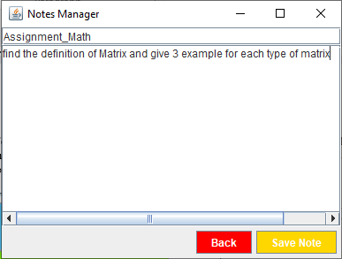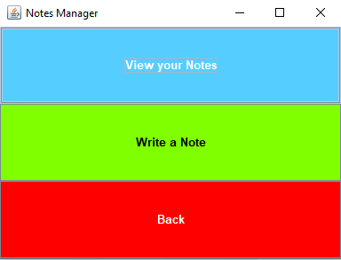

**Step 4.** In the view notes scene, your saved notes will be displayed alongside with 4 buttons, “View”, “Delete”, “Edit”, and “Back”. The functions of these buttons are self explanatory. If you done managing your notes, pressing the “Back” button will take you back into the main menu scene.

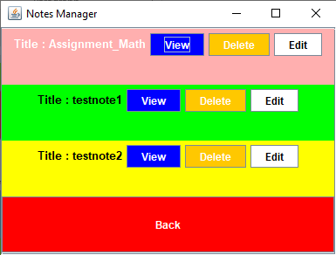

**Step 5.** To log out of your account press the “Back” button on the main menu scene and it will take you back into the user authentication scene.



**List of Exceptions**

In our application we only used two exceptions and they are built-in type of Exceptions, The exceptions that we used are the FileNotFoundException